**NAME : JANUTH ADITHA ABEYSINGHE**

**STUDENT ID : S225644509**

**UNIT : SIT725-APPLIED SOFTWARE ENGINEERING**

**TASK 3.2P**

**REPO LINK :** [**https://github.com/Janutimate/SIT725_s225644509.git**](https://github.com/Janutimate/SIT725_s225644509.git)

**SCREENSHOTS :**



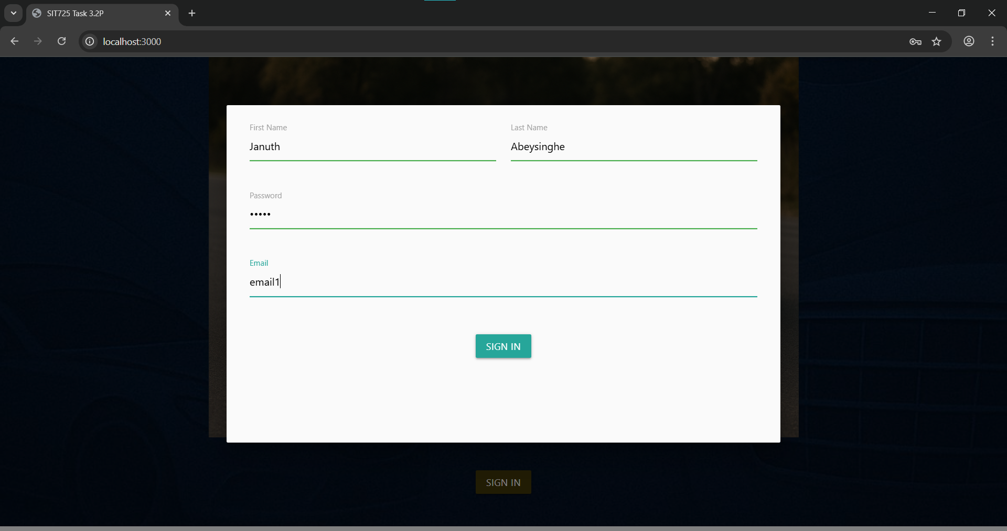

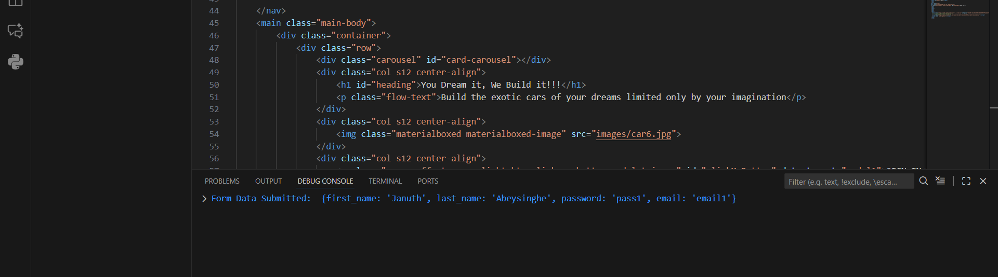

**WORKING CODE :**

